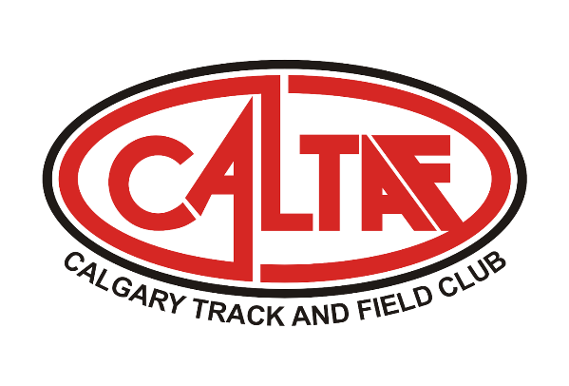
CALTAF ATHLETIC ASSOCIATION
Caltaf Follow the Sun – Road to Worlds Throws and Jumps Series

Purpose: To provide para and able body athletes the opportunity to achieve qualifying standards for the Worlds, Para Worlds, and the Commonwealth Games. These meets will allow athletes to obtain sanctioned performances to be included in the current Athletics Canada and world rankings for team selection and/or invites to National Championships. These meets must be flexible to take advantage of weather windows.

Meet #1
Dates: September 25, 2021. Weather delay September 26, 2021. Calgary Rotary Challenger Park (3688 48 Ave NE). There are concrete shot put, discus, and hammer circles. Change rooms and bathrooms are currently should be available.

These dates will be weather dependant. If we have to cancel a competition day due to weather, we will email participants the day before.

Schedule September 25th (weather delay same times on September 26th)

Saturday
13:00 | Discus – Men's/Women's/Para
14:15 | Shot Put – Men's/Women's/Para
15:00 | Javelin – Men’s/Women’s/Para
15:45 | Hammer – Men’s/Women’s

We are looking for sanctioning for both September 25th and 26th. However, depending on the weather, we plan to use only one day.

Events: Seated Javelin, Seated Shot, Shot (Para/Able body), Javelin (Para/Able body), Discus (Para/Able body), Hammer (Able body). Age Groups - U16 (born 2007-2006) to Masters (born 1986 and earlier). Preference will be given to high-performance athletes.

Entries
Entries will be invited only and may be limited based on time restrictions.

Entry Fees
$25.00 per event and will be paid by EFT.

Event Specifications:

Events | Gender | Para | Youth | Junior | Open
Shot Put | W / M | 3kg/4kg/3kg | 3kg./ 5 kg | 4kg / 6 kg | 4kg / 7.26 kg
Hammer | W/ / M |  | 3kg/5kg | 4kg/6kg | 4kg/7.26kg
Javelin | W/M | 600g/800g | 500g/700g | 600g/800g | 600g/800g
Discus | W/M | 1kg/1kg | 1kg/1.5kg | 1kg/1.75kg | 1kg/2kg

Weigh In Procedure
Weigh in for all implements will be held 1 hour before the start of the meet.

